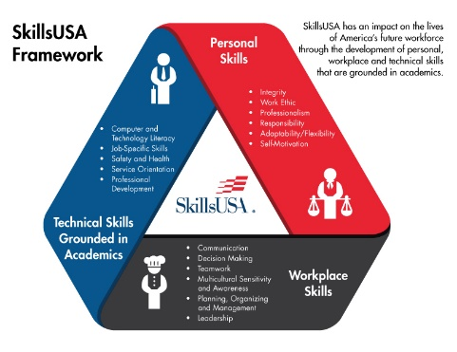
PURPOSE
To evaluate each contestant’s preparation for employment and to recognize outstanding students for excellence and professionalism in the field of welding.

TESTING:
Welding knowledge test given; hands-on evaluation of skill and blueprint reading ability.

ELIGIBILITY
3 contestants per region based on by regional competitions, in accordance with the SkillsUSA Ohio Program Guidelines

ORIENTATION
Orientation to begin at 10:00am in Exhibit Hall C. Orientation is for contestants only and is closed to advisors.

CLOTHING REQUIREMENTS
Suitable work clothing (to match service conditions for welding process employed, must be fire resistant)
    - Leather jacket, cape, sleeves or apron (optional)
    - Leather gloves
    - Hightop leather safety shoes or boots (steel toes recommended)
    - Welders hat or skullcap
    - Spectacles with side shields (clear lens)
    - Burning goggles or face shield (OFC & PAC)
        - 2 ea. #5 filter plate/lens
        - 2 ea. clear cover plate/lens
    - Noise protection (ear plugs)
    - Welding helmet
        - Spare batteries for helmet are recommended if you have auto lens
    - Welding lenses (to match helmet design)
        - 2 ea. shaded filter plate/lens (#10 or #11)
        - 2 ea. clear cover plate lens

TOOLS PROVIDED BY CONTESTANTS
- One copy of a 1-page typed personal résumé

Personal Tools:
- Carbon steel wire brush
- Stainless steel wire brush
- Grinder – attachments (no post weld grinding)
- Ball peen hammer, minimum 16 ounce
- Soapstone
- Two #2 pencils (sharpened)
- Center punch
- Metal scribe
- Steel dividers (radius maker min. 6”) or compass, to mark steel for cutting
- Handheld calculator

Measuring Devices:
- Steel tape measure (minimum 10’)
- Combination square set
- English steel bench rule (min. 12”)
- Protractor
- Metric ruler
- Chipping hammer
- Magnetic fixturing tool (optional)
- 10” mill file (half round-bastard cut) (optional)
- Cold chisel (size optional)
- Fillet weld gage
- Oxyfuel friction lighter (striker), flints and tip cleaners
- Pliers, wrenches and clamps
- Vice grips or vice grip type clamp
- Side or diagonal cutting pliers
- Groove or slip joint pliers
- Tank wrench (optional)
- Needle nosed pliers (optional)
- 12” adjustable wrench (optional)
- 3/32nd – 2% Th-2 Tungsten (red) (optional 2 pieces)
- 3/32nd – E3 Tungsten (purple) (optional 2 pieces)

TOOLS PROVIDED BY TECHNICAL COMMITTEE
Supplied Welding Equipment:
Stick, Tig, Mig and Flux Cored Welders Supplied by Lincoln Electric, Miller Electric and ESAB.
Supplied Welding Consumables:
Stick, Tig, Mig and Flux Cored consumables Supplied by Lincoln Electric, Miller Electric and ESAB

SPECIAL INFORMATION
- Beginning 2020 ALL SkillsUSA Ohio State Championships Contests will require a short interview component. Students should be prepared with basic job interview skills.
- No smart watches or phones are permitted during the contest.
- Contestants must have all applicable safety equipment listed above to participate.
- Contestants without all required “Personal Tools” will be allowed to participate, but may have difficulty completing some tasks without all required Personal Tools.
- All required tasks can be completed without personal tools listed as “optional.” However, some portions of the contest may be performed with greater ease by using these optional tools.
- Welding equipment is not to have any settings or connections changed by students during the walk through. Coupon material, electrodes and filler metal are not to be touched during the walk through.

SCOPE OF THE CONTEST
The contest will be judged based on the criteria established in the 2019-20 SkillsUSA National Technical Standards.

